**AIM:-** To design Non Deterministic Finite Automata using simulator to accept the string that start and end with different symbols over the input {a,b}.

**Diagram:**

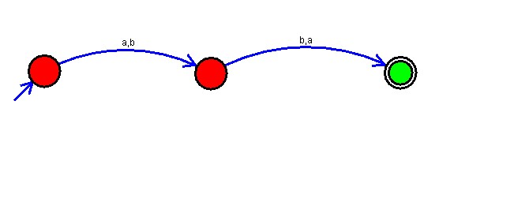

**Result:** Hence the string is accepted.